IP Camera
QUICK GUIDE FOR IE (for Windows XP/2003/Win7/Vista)

Document edition:V1.1

The manual for: V1.6(8).0.119 and above editions

Editions suit for IPC: Box IP camera, Infrared box IP camera, Dome IP camera, Speed dome IP camera

Preface
Thank you for using our IP camera products. This series of products are all-in-one IP cameras designed for network video surveillance, including box IP camera, infrared box IP camera, dome IP camera, speed dome IP camera, etc. The products adopt high performance and powerful single SOC chip media processor to integrate audio and video capture, compression and transmission. Standard H.264 Baseline and Main Profile coding algorithm ensures clearer and smoother video transmission effect. Built-in Web Server allows users to easily perform real-time monitoring and remote control over front-end cameras via IE browser.
This series of IP cameras is suitable for small and medium-sized enterprises, families, and other environments that require remote network video transmission and monitoring. It is easy to install and operate.

Table of Contents
1 Download and install ActiveX 4
2 Login 6
3 System information 7
Network Interface of IP Camera 9
Default Parameters 9
Basic FAQs 9

1, cables for IP camera
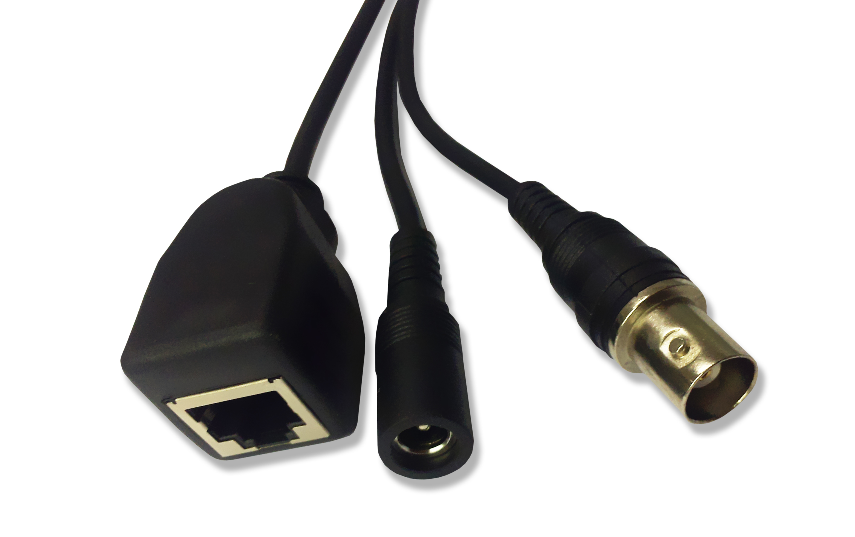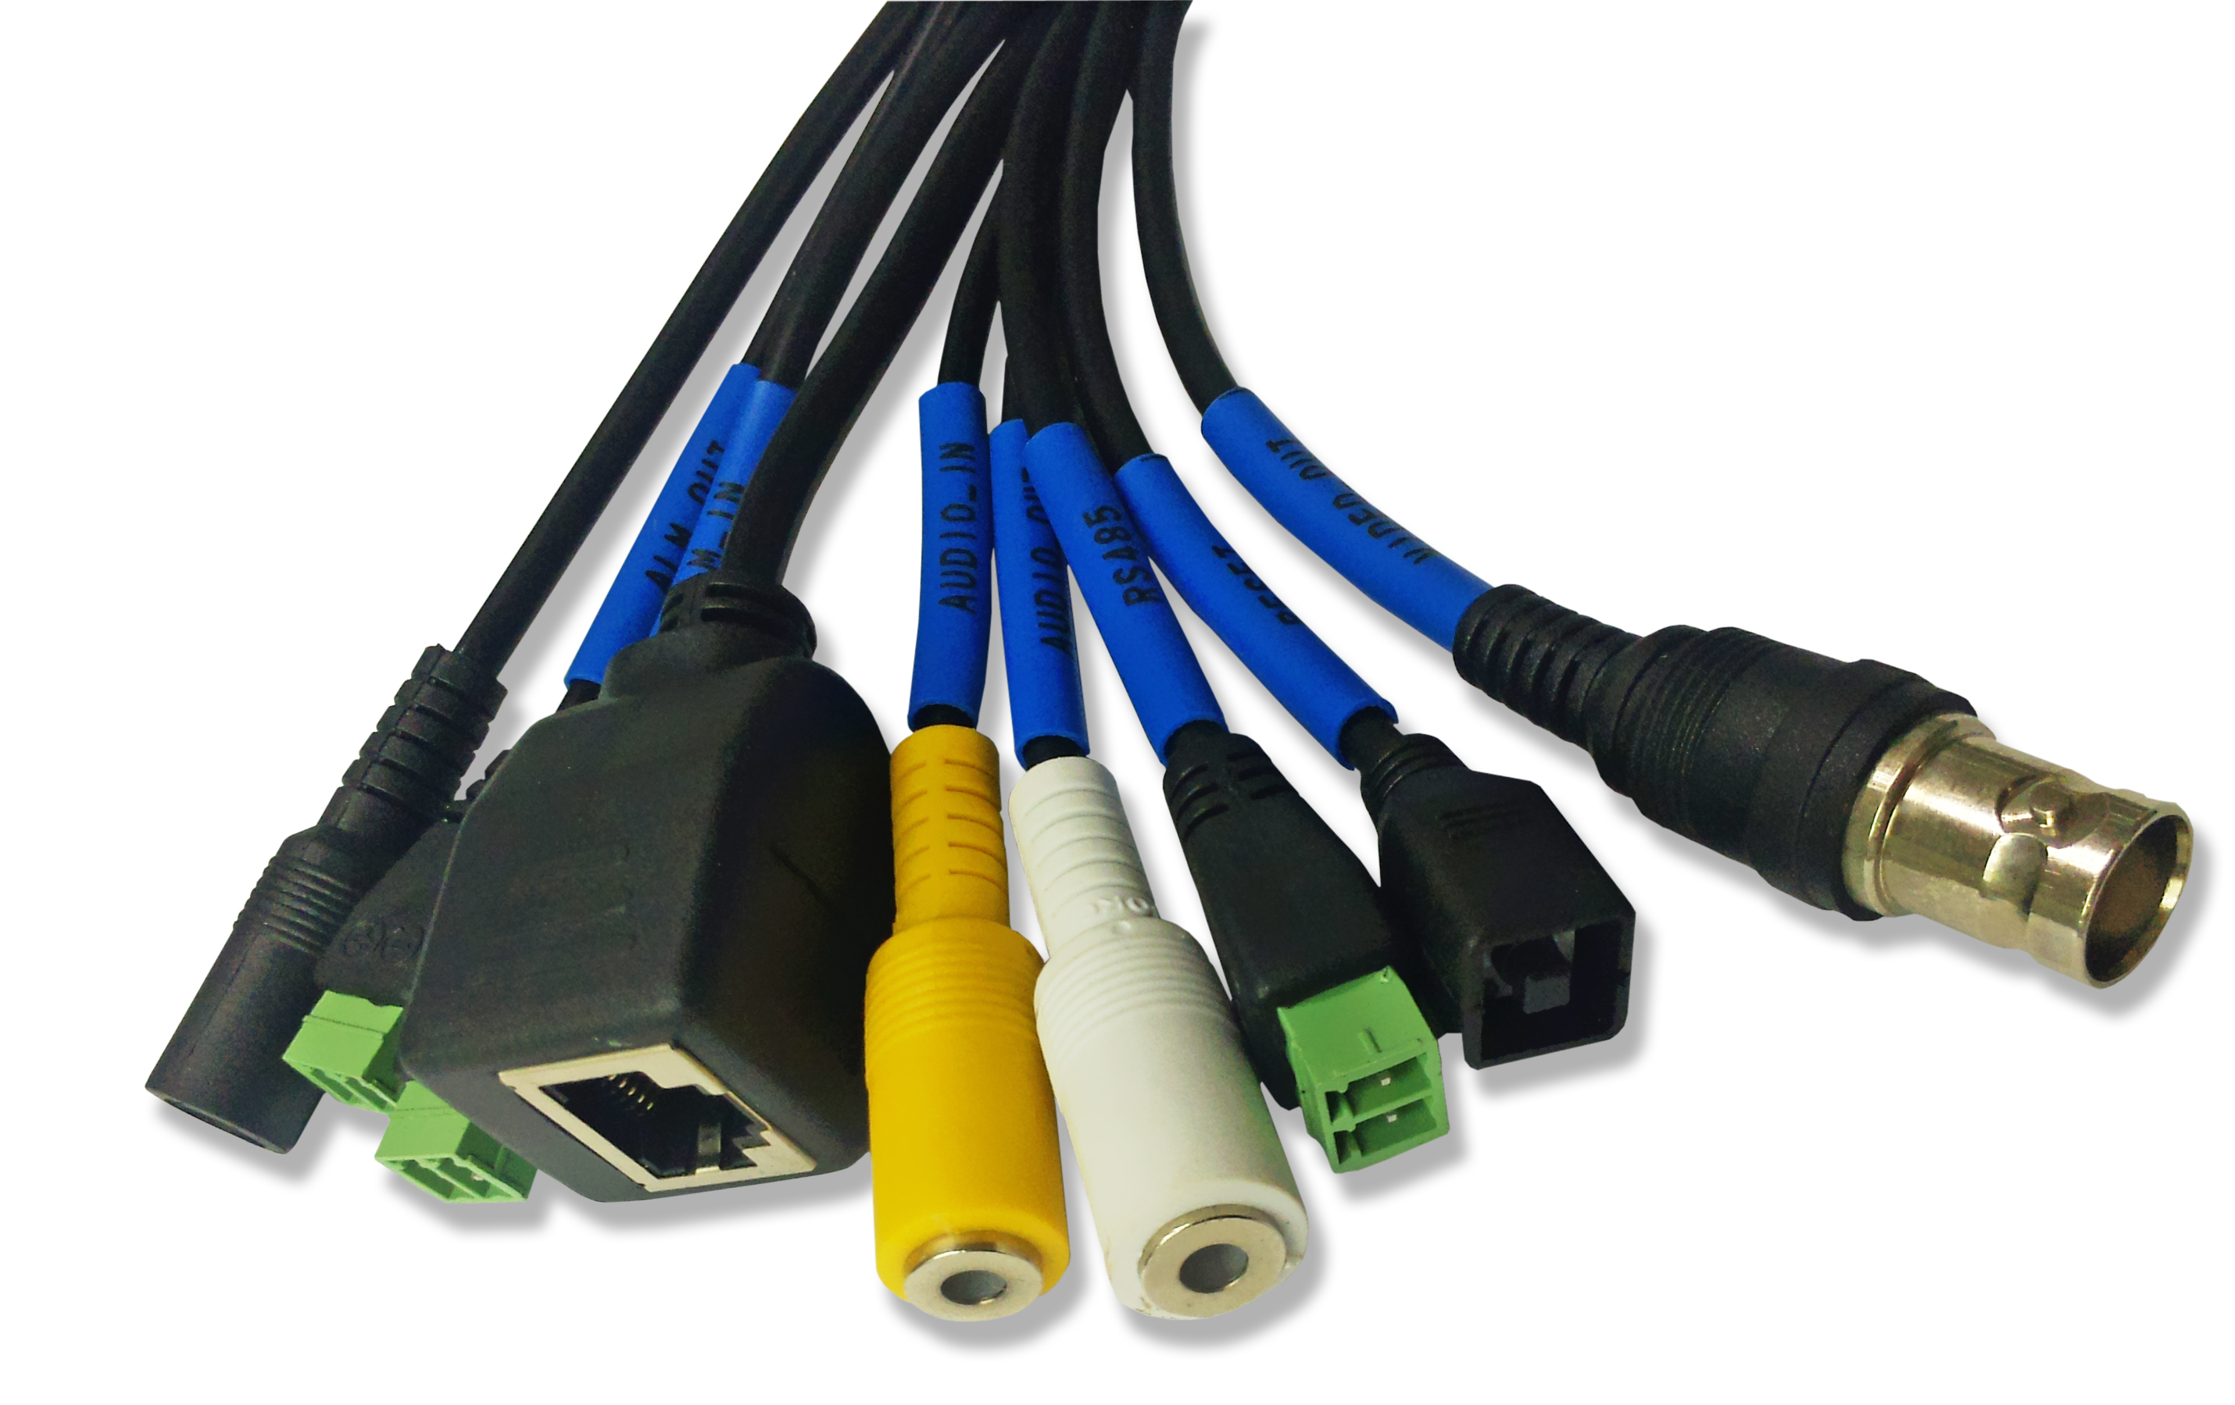
power
BNC
output
reset
alarm in
RJ45
power
BNC output
RS485
audio out
audio in
RJ45
alarm out

Camera model | Power supplier standard
Box camera without IR function | DC12V,1A
IR camera | DC12V,3A

2, Network Interface of IP Camera
The default network ports of IP camera are:
TCP | 80 | Web port
TCP | 5000 | Communication port, audio/video data transmission port, talkback data transmission port
UDP | 5000 | Audio/video data transmission port
ONVIF | 2000

Users can check the port as follow path:Config->Network settings->Basic

3, Default Parameters
Default parameters
Cabled Network:
IP Address: 192.168.1.88 Data Port: 5000 Subnet mask: 255.255.255.0 Web Port: 80
ONVIF port: 2000 Gateway: 192.168.1.1 DHCP: OFF
DNS: 8.8.8.8
User: admin
Password: admin

4, Download and install ActiveX
You need to install ActiveX Control when you visit IP camera for the first time through IE browser.
ActiveX installing method:
Download installation
Input the IP address of IP camera in Internet Explore to enter into login page(see Figure 1),
Click [File] to download the ActiveX:
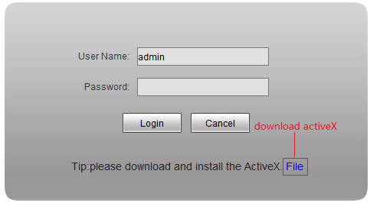 Figure 1
You can download the ActiveX manually or just input the password,then download the file as system prompt.(see Figure 2)
Figure 2
File download dialogue box pops up, click [Run] or [Save] to download ActiveX, after download it , double-click the downloaded file “WebCMS.exe” and choose the language, then install it.
NOTE: Abnormal phenomenon when install ActiveX and the solutions:
1: when install the ActiveX,it pops up the window as Figure 3:

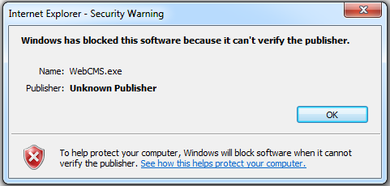
Figure 3
please change the security level of IE, IE tools-> Internet options->Security->Custom level as
Figure 4, and change the parameters as Figure 5, Figure 6:
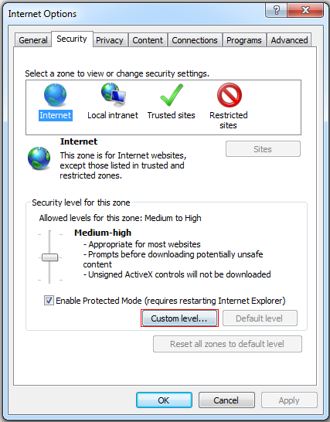
Figure 4

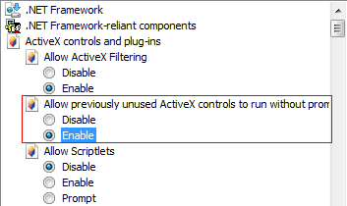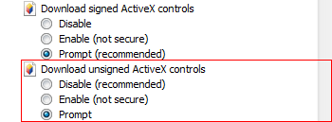
Figure 5

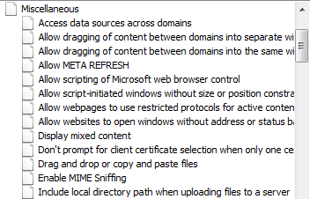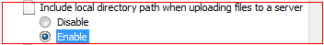
Figure 6

2: when install the ActiveX,it pops up the window as follow, please close the IE and CMS,then click “retry”.
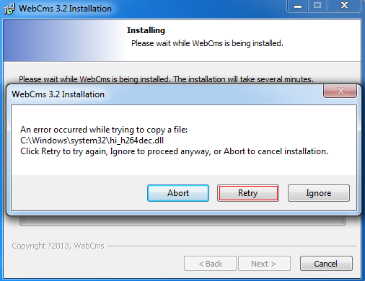

5, Login
Before login the camera, please confirm that, the network segment of the camera and local PC is the same. Eg: IP address of camera is 192.168.1.100, so the IP address of local pc should be 192.168.1.*** .
The default IP address of camera is 192.168.1.88, so we should check the IP address of PC in the network segment 192.168.1.*** or not. Start->run->CMD, input the command ipconfig -all to check the IP address of PC, if the IP in the 192.168.1.*** as follow, so we can access the camera:
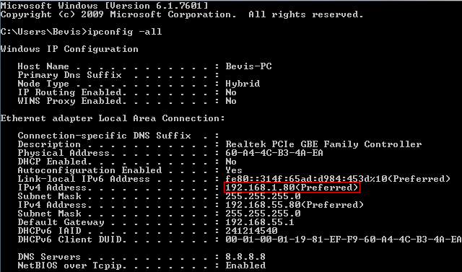
If not, for example, the IP of PC is 192.168.55.80,we can add a new network segment to PC, open network and sharing center->local area connection->priorities->Internet Protocol Version 4(TCP/IPv4)->priorities.use the following IP address,input the IP address,subnet mask,gateway and DNS, which you can get from the picture above, then click “advance” to add a new network segment, and click add, until finish it.
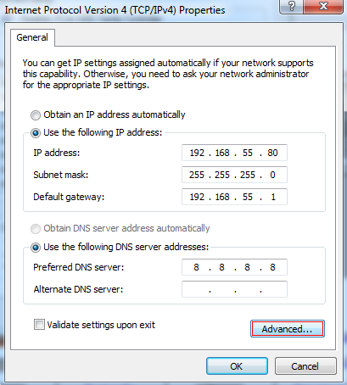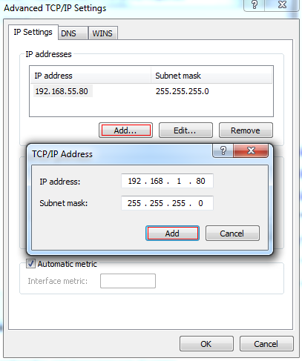
Reopen Internet Explorer after ActiveX installation completes, input IP address of the IP camera to turn to login page, enter username and password (default setting is admin/admin), click login to enter into main interface(see Figure 7):
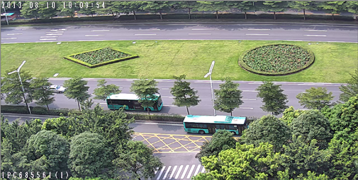
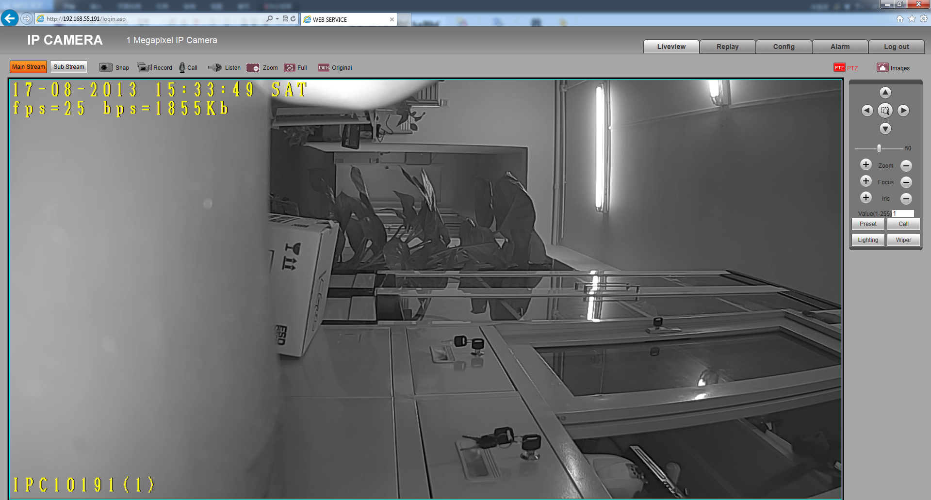
Figure 7

6, Main function brief introduction
The main icon and function in the main interface list as follow :
 | Call the Main stream |  | Call the Sub stream
 | Manual snapshot |  | Manual record
 | Dual audio |  | One way audio
 | Digital Zoom |  | Full screen
 | Original W:H ratio |  | PTZ Control
 | Adjust images value

For manual snapshot and record, the images and recording files will keep in the path,please reference config->local config->record file path.
For listen function, it works when audio enabled, audio disable as default.

For images, we can set more parameters, config->video settings->video parameters.

3 System information
Check System information and change language of camera:

After login the camera, follow the path:Config->System->System Info to check the information of camera
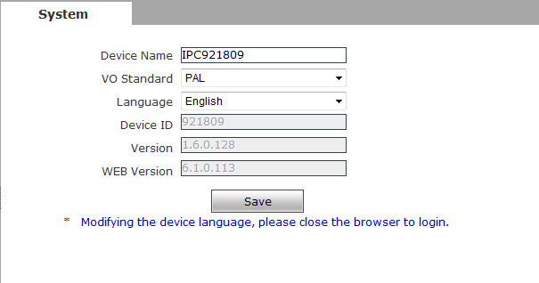
Figure 42
[Language]: Support Chinese and English, after changing the language,please reopen the IE browser to login the camera again.

System upgrade:
After login the camera, Config->System->Upgrade, and will see the window as follow:
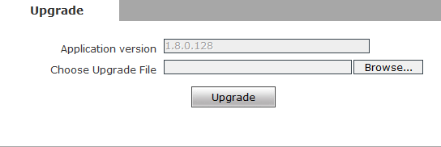
Figure 45
Click “Browse” button, and select correct file of upgrade (kernel file, suffix.uot),click [upgrade], then you can upgrade your system, the completion rate will be displayed during this process. After upgrade completes, IP camera will restart automatically. Re-log in device, enter into system settings page, check to see whether the kernel edition is the upgraded edition.

 Notice：
- Don’t cut off the power and internet connection while upgrading.

Basic FAQs
1、 Forget Password
Solution: There is a [RESET] button on the back panel of the IP camera, press it 1-2 seconds, then loosen it 1-2 seconds, and try 3 times . Camera will restore all default parameters (Factory Settings), user name and password are both “admin”. And IP address is 192.168.1.88

Notice：Please don’t press RESET if you are not a professional operator. After reset, all parameters will restore factory settings (except for the physical network address).

- No video image displayed in IE browser
Possible reason: ActiveX not installed
Solution: ActiveX must be installed when visiting IP camera for the first time via Internet Explore.
How to install: Visit IP camera, click [file], file download dialog will pop up, select [Run] or [Save] to download. Please reference the ActiveX install part to install the ActiveX.
- Fail to visit IP camera via IE after upgrade
Solution: Delete the caching of Browser.
Steps: Open IE—click “Tools”—select “Internet Options”—click “delete files” button in “Internet temporary files”, select “delete all offline contents”, then click “OK” and re-log in IP camera.
END

